Question:

The activity data of a user is given.

i) Your job is to cluster the data using its location. Apply the K-means clustering algorithm preferably with 3 clusters and plot them. The dataset contains 250+ columns. *Location:log_latitude_range* and *Location:log_longitude_range* represents the location of a particular user.

The result of first question could follow this:

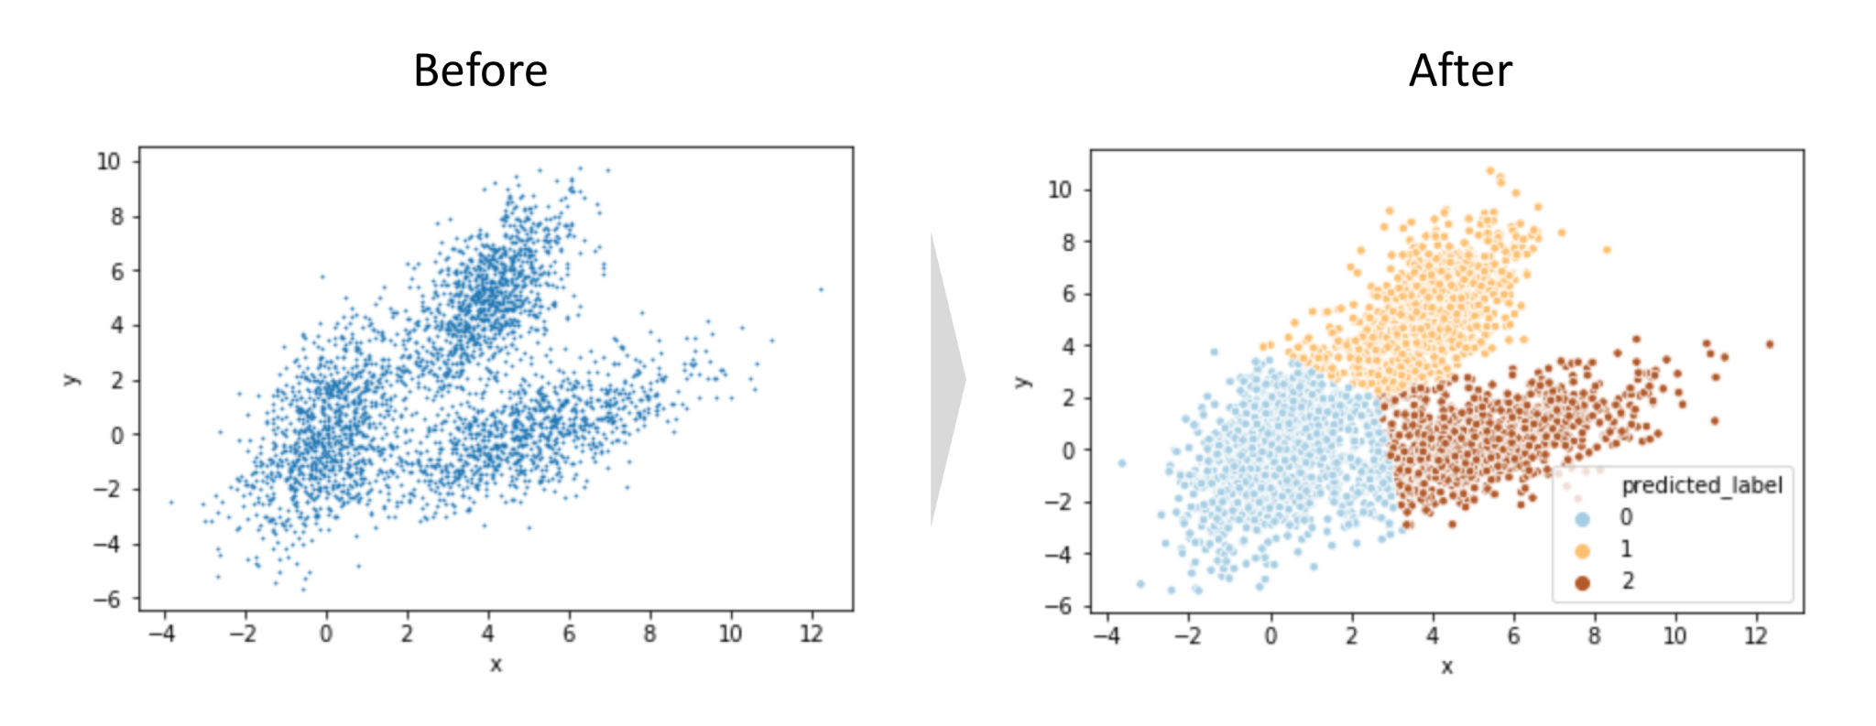

ii) After clustering the data, your job is to find the Activity performed by the user at any of the clustered locations. Take only *Sitting*, *Lying_down*, *Fix_running*, *Fix_walking,* and *OR_standing* activities and plot them in percentages.

The sample pie plot of activities is given.

